**Lesson Notes**

1. What is the main purpose of an Operating System?
   1. Handles the computer hardware
   2. Handles resource allocation
   3. Provide a standard user interface(windows)
   4. Provide a standard way to store and browse data files and folders
   5. Provides ownership control
   6. Schedules the CPU
2. What is the difference between Operating System Software and Use Application Software?
   1. `Same applications can run on different computer hardware
   2. Must be configured according to hardware components present in the computer
   3. Applications focus on what is contained and displayed within in a window.
   4. Operating System controls opening/closing/resizing and responding mouse and keyboard actions
   5. Operating System provides standard ways to print, save and open files, access the internet, etc.
3. What is the difference between Operating System Software and Computer Hardware?
   1. An Operating System manages computer hardware and software resources and provides common services for computer programs
   2. Computer Hardware, is the components that make up the computer as a whole.
4. What are the main parts of an Operating System?
   1. Graphical User Interface (GUI)
      1. Windows Display, Mouse. Keyboard, Sound, etc.
   2. System Calls
   3. Device Drivers
   4. I/O Manger
   5. Memory Manger
   6. Process Manger
   7. Security Manger
5. What are some popular operating systems?
   1. Windows OS
   2. Mac OS
   3. Linux / Unix
   4. Android
   5. IOS

**Reference Diagram**

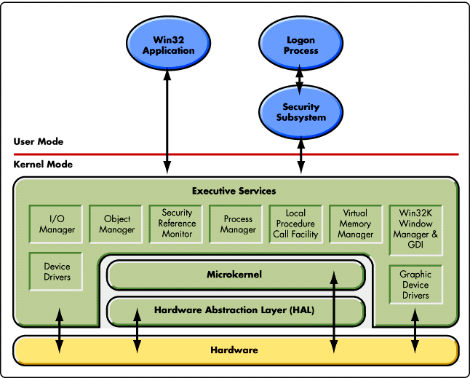

Graphics Card

Local Printer

Window

Manager

Task Manager

DLL

**Student Questions**

1. What is a device driver?
   1. Provide a brief summary
      1. It is a file that lets the computer know the configuration and specifications of a certain hardware device. Without the driver file, the computer will be unable to communicate with the device.
   2. List some devices that require a device driver.
      1. DVD drives and PCI cards
   3. Provide a label on the reference diagram for the location of a device driver for your graphics card.
   4. Provide a label on the reference diagram for the location of a device driver for a locally attached printer.
2. What is a DLL?
   1. Provide a brief summary
      1. It is a dynamic link library file format used for holding multiple codes and procedures for Windows programs. DLL files were created so that multiple programs could use their information at the same time, aiding memory conservation.
   2. Explain how DLLs are related to user application programs
      1. DLLS are related to user application programs since it helps with allowing multiple things to run, since they can all run at the same time, instead of individually.
   3. Provide a label on the reference diagram for the location of a DLL
3. What is a windows manager?
   1. Provide a brief summary
      1. A Window Manager is a program responsible for coordinating all the windows on the screen
   2. Explain how a windows manager is related to user application programs
      1. It is related since it allows the user to view multiple application windows at once, instead of one at a time.
   3. Provide a label on the reference diagram for the location of a DLL
4. What is the windows task manager?
   1. Provide a brief summary
      1. Task Manager, is a Windows feature that provides details about programs and processes running on your computer. It also displays the most commonly used performance measures for processes. Provides details on current programs and see what programs have stopped responding.
   2. List and explain four (4) types of system information provided by the task manager
      1. CPU usage (Self-explanatory)
      2. Memory usage (Self-explanatory)
      3. Disk usage (Self-explanatory)
      4. Network usage (Self-explanatory)
   3. Provide a label on the reference diagram for the operating system components related to each type of information.